Batch: A2 Roll No.: 16010322014
Experiment / assignment / tutorial No. 2
Grade: AA / AB / BB / BC / CC / CD /DD
Signature of the Staff In-charge with date

Title: Configure Router Settings
Objectives:
Part 1: Set Up the Topology and Initialize Devices
• Cable equipment to match the network topology.
• Initialize and restart the router and switch.
Part 2: Configure Devices and Verify Connectivity
• Assign static IPv4 and IPv6 information to the PC interfaces.
• Configure basic router settings.
• Configure the router for SSH.
• Verify network connectivity.
Part 3: Display Router Information
• Retrieve hardware and software information from the router.
• Interpret the output from the startup configuration.
• Interpret the output from the routing table.
• Verify the status of the interfaces
OUTCOME:
CO 1. Understand switched networks and Implement Virtual LAN (VLAN)

Tools required:
• 1 Router (Cisco 4221 with Cisco IOS XE Release 16.9.4 universal image or comparable)
• 1 Switch (Cisco 2960 with Cisco IOS Release 15.2(2) lanbasek9 image or comparable)
• 2 PCs (Windows with a terminal emulation program, such as Tera Term)
• Console cables to configure the Cisco IOS devices via the console ports
• Ethernet cables as shown in the topology
Note: The Gigabit Ethernet interfaces on Cisco 4221 routers are autosensing and an Ethernet straight-through cable may be used between the router and PC-B. If using another model Cisco router, it may be necessary to use an Ethernet crossover cable.

Theory:
A router is a networking device that forwards data packets between computer networks. Routers perform the traffic directing functions on the Internet. Data sent through the internet, such as a web page or email, is in the form of data packets. A packet is typically forwarded from one router to another router through the networks that constitute an internetwork (e.g. the Internet) until it reaches its destination node.
A router is connected to two or more data lines from different IP networks. When a data packet comes in on one of the lines, the router reads the network address information in the packet header to determine the ultimate destination. Then, using information in its routing table or routing policy, it directs the packet to the next network on its journey.

The most familiar type of IP routers are home and small office routers that simply forward IP packets between the home computers and the Internet. More sophisticated routers, such as enterprise routers, connect large business or ISP networks up to the powerful core routers that forward data at high speed along the optical fiber lines of the Internet backbone.

Task:

Topology

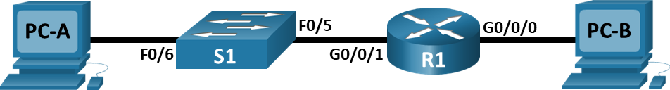

Addressing Table
Device | Interface | IP Address / Prefix | Default Gateway
R1 | G0/0/0 | 192.168.0.1 /24 | N/A
R1 | G0/0/0 | 2001:db8:acad::1 /64 | N/A
R1 | G0/0/0 | fe80::1 | N/A
R1 | G0/0/1 | 192.168.1.1 /24 | N/A
R1 | G0/0/1 | 2001:db8:acad:1::1 /64 | N/A
R1 | G0/0/1 | fe80::1 | N/A
R1 | Loopback0 | 10.0.0.1 /24 | N/A
R1 | Loopback0 | 2001:db8:acad:2::1 /64 | N/A
R1 | Loopback0 | fe80::1 | N/A
PC-A | NIC | 192.168.1.10 /24 | 192.168.1.1
PC-A | NIC | 2001:db8:acad:1::10 /64 | fe80::1
PC-B | NIC | 192.168.0.10 /24 | 192.168.0.1
PC-B | NIC | 2001:db8:acad::10 /64 | fe80::1

Step 1: Establish a console connection to R1.
- Choose a Console cable from the available connections.
- Click PCA and select RS 232.
- Click R1 and select Console.
- Click PCA > Desktop tab > Terminal.
- Click OK and press ENTER. You are now able to configure R1

Step 2: Enter privileged mode and examine the current configuration
You can access all the router commands from privileged EXEC mode. However, because many of the privileged commands configure operating parameters, privileged access should be password- protected to prevent unauthorized use.
- Enter privileged EXEC mode by entering the enable command.

Router> enable Router#
Notice that the prompt changed in the configuration to reflect privileged EXEC mode.
b. . Enter the show running-config command. Router# show running-config

What is the router’s hostname?
Ans: Rack5_R2

How many Fast Ethernet interfaces does the Router have?
Ans: 0
How many Gigabit Ethernet interfaces does the Router have?
Ans: 3
How many Serial interfaces does the router have?
Ans: 0
What is the range of values shown for the vty lines?
Ans: 0-4

c. Display the current contents of NVRAM.

Router# show startup-config startup-config is not present

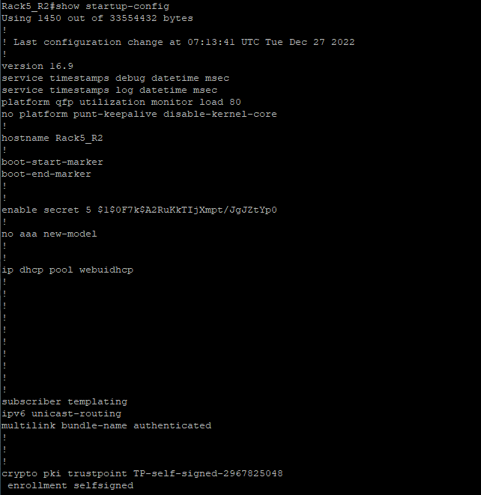

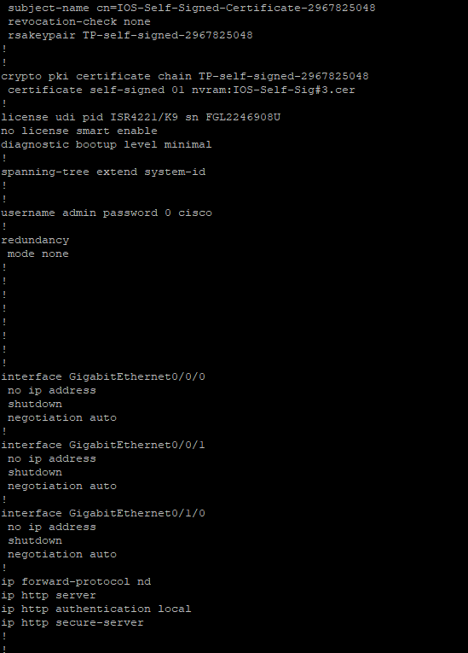

Part 2: Configure and Verify the Initial Router Configuration
To configure parameters on a router, you may be required to move between various configuration modes. Notice how the prompt changes as you navigate through the IOS configuration modes.

Step 1: Configure the initial settings on R1.
- Configure R1 as the hostname.

- Configure Message of the day text: Unauthorized access is strictly prohibited.
- Encrypt all plain text passwords Use the following passwords:
  - Privileged EXEC, unencrypted: cisco
  - Privileged EXEC, encrypted: itsasecret
  - Console: letmein

Step 2: Verify the initial settings on R1.
    - Verify the initial settings by viewing the configuration for R1.

What command do you use?
Ans: show running-config

    - Exit the current console session until you see the following message: R1 con0 is now available
Press RETURN to get started
    - Press ENTER; you should see the following message: Unauthorized access is strictly prohibited.
User Access Verification Password:

Why should every router have a message-of-the-day (MOTD) banner?

Ans:
The Message of the Day (MOTD) banner will be displayed before the user authenticates to our devices. It is typically used to display a temporary notice that may change regularly, such as system availability.
If you are not prompted for a password before reaching the user EXEC prompt, what console line command did you forget to configure?
Ans:

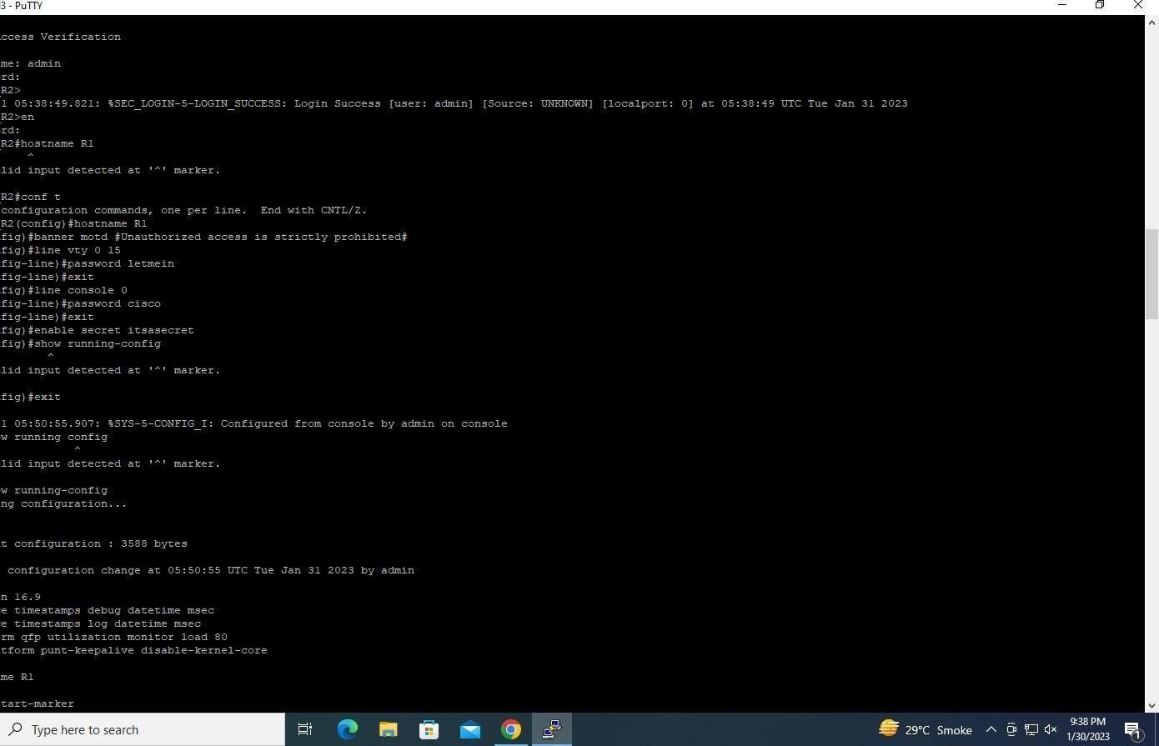
line console0 password cisco
d. Enter the passwords necessary to return to privileged EXEC mode

If you configure any more passwords on the router, are they displayed in the configuration file as plain text or in encrypted form? Explain

Ans: Encrypted text.

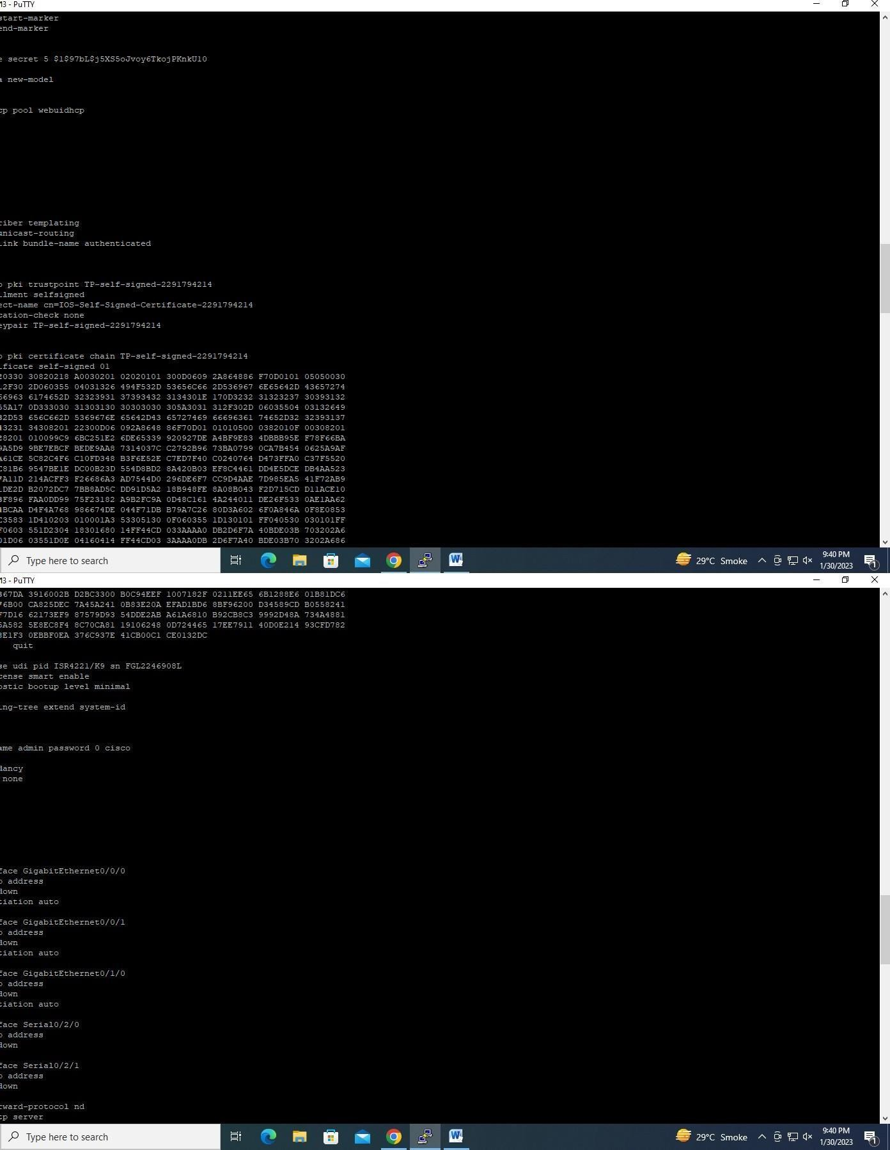

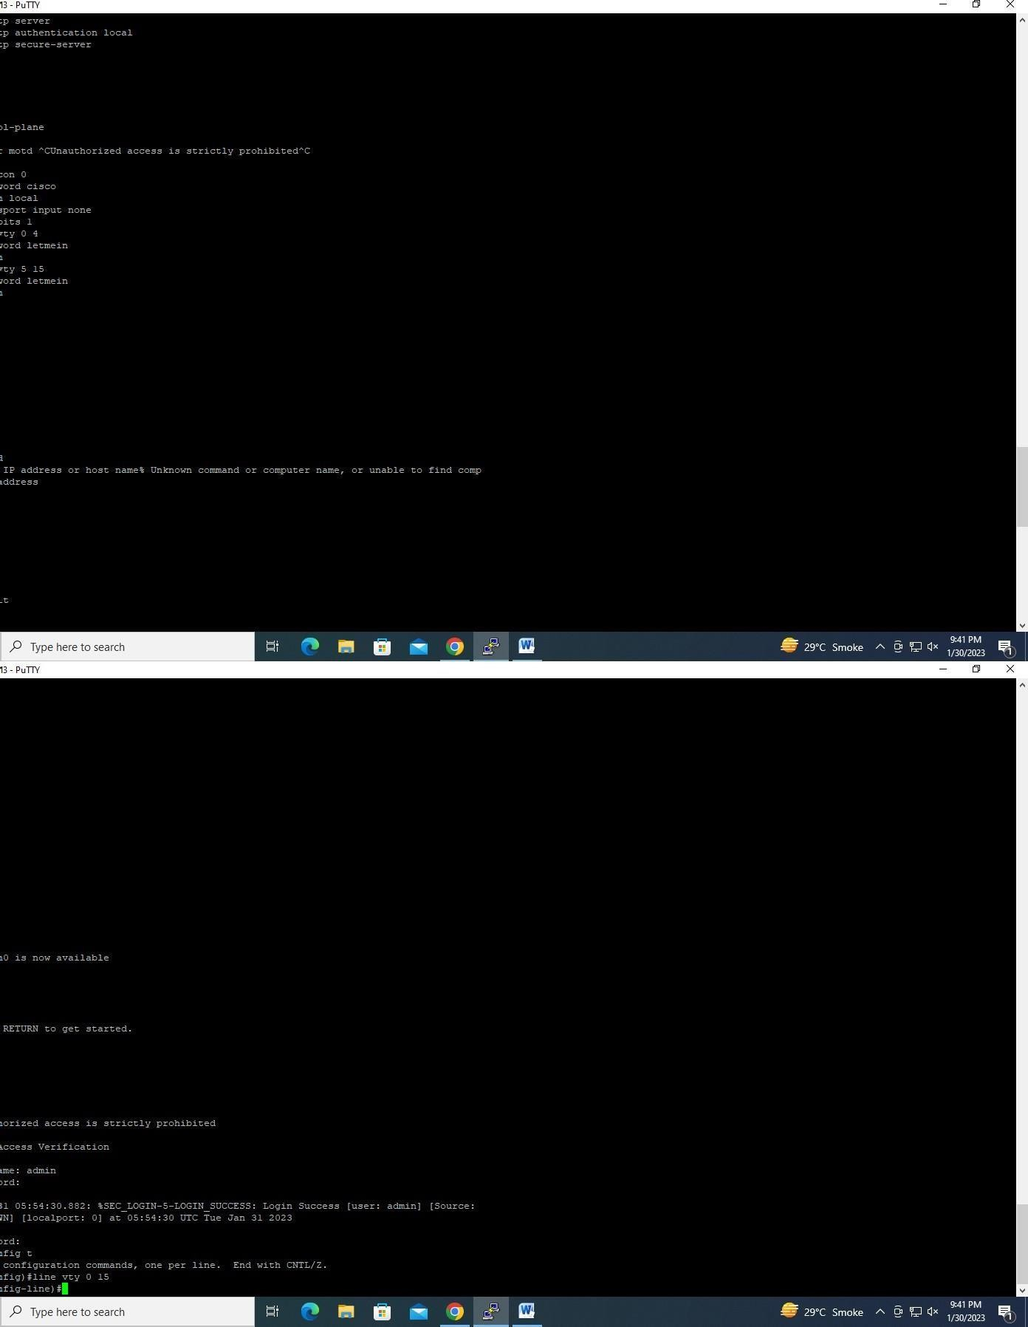

.

Part 3: Save the Running Configuration File Step 1: Save the configuration file to NVRAM.
a. You have configured the initial settings for R1. Now back up the running configuration file to NVRAM to ensure that the changes made are not lost if the system is rebooted or loses power
What command did you enter to save the configuration to NVRAM?
Ans: copy running-config startup-config

Step 2: Optional: Save the startup configuration file to flash.
Although you will be learning more about managing the flash storage in a router in later chapters, you may be interested to know that, as an added backup procedure, you can save your startup configuration file to flash. By default, the router still loads the startup configuration from NVRAM, but if NVRAM becomes corrupt, you can restore the startup configuration by copying it over from flash.
Complete the following steps to save the startup configuration to flash.
- Examine the contents of flash using the show flash command: R1# show flash

How many files are currently stored in flash? 4
Which of these files would you guess is the IOS image?

.bin files

- Use the show flash command to verify the startup configuration file is now stored in flash.

Why do you think this file is the IOS image?

IOS image files contain the system code that your router uses to function, that is, the image contains the IOS itself

R1# copy startup-config flash
Destination filename [startup-config]

The router prompts you to store the file in flash using the name in brackets. If the answer is yes, then press ENTER; if not, type an appropriate name and press ENTER.

Procedure:
Part 1: Verify the Default Router Configuration
Select ISR 4331 router
Step 1: Establish a console connection to R1.
- Choose a Console cable from the available connections.
- Click PCA and select RS 232.
- Click R1 and select Console.
- Click PCA > Desktop tab > Terminal.
- Click OK and press ENTER. You are now able to configure R1

Step 2: Enter privileged mode and examine the current configuration
You can access all the router commands from privileged EXEC mode. However, because many of the privileged commands configure operating parameters, privileged access should be password- protected to prevent unauthorized use.
- Enter privileged EXEC mode by entering the enable command. Router> enable
Router#
Notice that the prompt changed in the configuration to reflect privileged EXEC mode.
- . Enter the show running-config command. Router# show running-config
What is the router’s hostname?

Ans: Rack5_R2

How many Fast Ethernet interfaces does the Router have?
Ans: 0

How many Gigabit Ethernet interfaces does the Router have?
Ans: 3
How many Serial interfaces does the router have?
Ans: 0
What is the range of values shown for the vty lines?
Ans: 0-4

c. Display the current contents of NVRAM.

Router# show startup-config startup-config is not present

Part 2: Configure and Verify the Initial Router Configuration
To configure parameters on a router, you may be required to move between various configuration modes. Notice how the prompt changes as you navigate through the IOS configuration modes.

Step 1: Configure the initial settings on R1.
- Configure R1 as the hostname.

- Configure Message of the day text: Unauthorized access is strictly prohibited.
- Encrypt all plain text passwords Use the following passwords:
  - Privileged EXEC, unencrypted: cisco
  - Privileged EXEC, encrypted: itsasecret
  - Console: letmein

Step 2: Verify the initial settings on R1.
    - Verify the initial settings by viewing the configuration for R1.

What command do you use?
Ans: show running-config

    - Exit the current console session until you see the following message: R1 con0 is now available
Press RETURN to get started
    - Press ENTER; you should see the following message: Unauthorized access is strictly prohibited.
User Access Verification Password:

Why should every router have a message-of-the-day (MOTD) banner?

Ans:
The Message of the Day (MOTD) banner will be displayed before the user authenticates to our devices. It is typically used to display a temporary notice that may change regularly, such as system availability.
If you are not prompted for a password before reaching the user EXEC prompt, what console line command did you forget to configure?
Ans:

line console0 password cisco
d. Enter the passwords necessary to return to privileged EXEC mode

If you configure any more passwords on the router, are they displayed in the configuration file as plain text or in encrypted form? Explain

Ans: Encrypted text.

.

Part 3: Save the Running Configuration File Step 1: Save the configuration file to NVRAM.
a. You have configured the initial settings for R1. Now back up the running configuration file to NVRAM to ensure that the changes made are not lost if the system is rebooted or loses power
What command did you enter to save the configuration to NVRAM?
Ans: copy running-config startup-config

Step 2: Optional: Save the startup configuration file to flash.
Although you will be learning more about managing the flash storage in a router in later chapters, you may be interested to know that, as an added backup procedure, you can save your startup configuration file to flash. By default, the router still loads the startup configuration from NVRAM, but if NVRAM becomes corrupt, you can restore the startup configuration by copying it over from flash.
Complete the following steps to save the startup configuration to flash.
- Examine the contents of flash using the show flash command: R1# show flash

How many files are currently stored in flash? 4
Which of these files would you guess is the IOS image?

.bin files

- Use the show flash command to verify the startup configuration file is now stored in flash.

Why do you think this file is the IOS image?

IOS image files contain the system code that your router uses to function, that is, the image contains the IOS itself

R1# copy startup-config flash
Destination filename [startup-config]

The router prompts you to store the file in flash using the name in brackets. If the answer is yes, then press ENTER; if not, type an appropriate name and press ENTER.

Signature of faculty in-charge with Date

